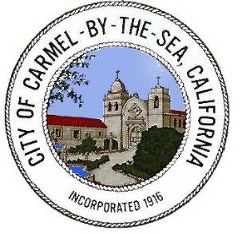
PUBLIC NOTICE

San Carlos Median Island
Landscaping Project
Public Workshop

The City of Carmel Public Works Department will be giving a presentation on the history of the San Carlos Median Islands. They will review comments from the first Public Workshop held in January of 2020, and from the Forest and Beach Commission meeting in November of 2022, as well as discuss the current project status.

The Public Works Department is asking for your feedback on the following: Two longer medians, four shorter medians, or preference for no medians along San Carlos between Tenth and Thirteenth Avenues, as well as optional landscaping themes, upon approval by the City Council. There will be an opportunity to ask the Project Team questions.

Residents interested in this presentation are invited to attend the meeting in person.

Date: Thursday, January 26, 2023
Time: 4:00 pm – 7:00 pm
Location: Sunset Center, Babcock Room

