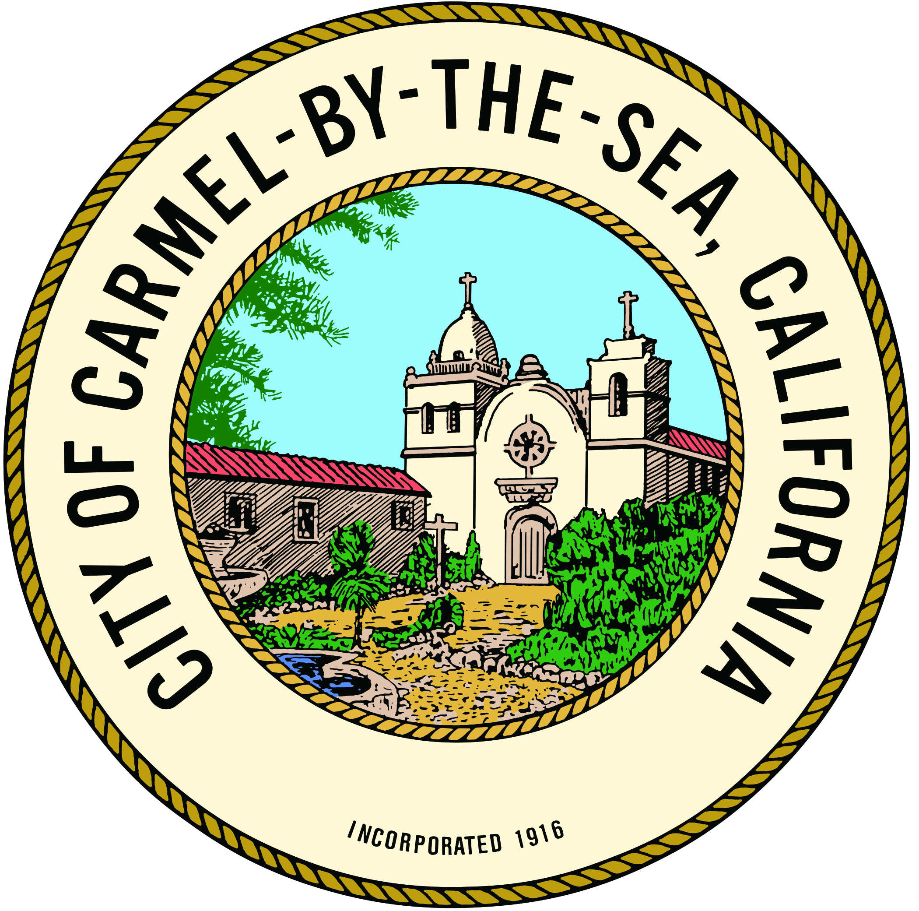
CITY OF CARMEL-BY-THE-SEA

NOTICE OF NOMINEES FOR PUBLIC OFFICE

NOTICE IS HEREBY GIVEN that the following persons have been nominated for the offices designated to be filled at the General Municipal Election to be held in the City of Carmel-by-the-Sea on Tuesday, November 8, 2022.

For Mayor - VOTE FOR NO MORE THAN ONE
Dave Potter

For Member of the City Council - VOTE FOR NO MORE THAN TWO
Jeff Baron
Alissandra Dramov
Daniel Parker Logan
Ashley Stoddard

The polls will be open between the hours of 7:00 a.m. and 8:00 p.m.

Nova Romero, MMC
City Clerk
Carmel-by-the-Sea, CA
Dated: August 23, 2022
Posted: August 24, 2022
Publish Date: August 26, 2022

